**Chapter No. 6**

**System Development**

**System Development**

Once the system is proposed and software design phase has been accomplished, the designer moves towards the development phase of the software in accordance with proposed system and design phase specification.

The conversion of the existing system into computerization processing requires the development of computer programs for the proposed system. Software development is an important phase. Special care is to be taken because it may cause heavy loss even a situation may arise redevelopment of the whole system. It is more practical, because it involves the realization of the actual system.

Computer programs are written and arrangements are made to train the personnel. The main purpose of this phase is to develop the software package that meets the requirements of user.

**6.1 Methods of the Development Phase**

The development phase of the proposed system includes the following methods.

* Coding
* Compilation of programs
* Testing of programs
* **Coding**

Data coding is a common practice. There are many ways to plan a code. This subject is very complex. The group classification codes have been used for the system, because codes can be easily generated by these methods.

* **Compiling of Program**

When all the coding of programs has been completed, then the programs are compiled by using the available compiler by the system on which the development has been done.

* **Testing of the System**

Testing is the process of executing an implementation of a system with test data and examining the output of the system and its operational behavior to check whatever it is performing as required. One of the main objectives of testing is to establish the presence of defect in a program. Testing can only establish the existence of defects whereas debugging locates and correct the defects.

Testing can also judge whether or not this particular application is usable in practice. Therefore a suitable approach must be chosen to reduce the possibility of errors in system.

Among the rules that serve well as program testing objectives are:

* Testing is a process of program execution with explicit intents to find errors and run-time program bugs.
* A successful test is not one that uncovers only few expected errors, but it is also one that constantly provides new challenges to its programmer over time.
* An effective test case is one that contains unexpected testing record set with high probability of detecting undiscovered errors during the program design and development phases.

**6.2 Unit Testing**

In this phase, a set of basic tests at the module level was performed. The testing of each module was done repeatedly. The problem identified during the last test was corrected, before a new test was carried out. This approach was taken to ensure the modules meet the objectives defined and the unit work appropriately.

**6.3 Black Box Testing**

Functional or black box testing is an approach to testing, where the test are derived from the program or component specification. System is like a black box whose behavior can only be determined by considering an input test and viewing its output. The tester is only concerned with the functionality. If the out put is not as predicted, then the test has successfully detected a problem with mange the stock. The testers are usually the end users themselves.

**6.4 White Box Testing**

Structural or white box testing is an approach to testing, where the tests are derives from knowledge of the software’s structure and implementation. This approach is usually applied to relatively small program units such as subroutines or the operations associated with an object. The tester’s analysis the code and uses knowledge about the structure of a component to derive test data. The analysis of the code was used to find how man test cases were needed to guarantee that all of the statements in the program or component are executed at least once during the testing process.

**6.5 Integration Testing**

This testing approach was conducted once individual program units have been tested. After combination of all the modules contained in system check for the complete system for functionality, with emphasis on the modular interface (input/output parameters).

**6.6 Interface Testing**

Interface testing was conducted to detect faults, which may have been introduced into Application interface errors on invalid assumptions about the interfaces.

The buttons were checked to ensure that they pointed to the exact source. For example, the developer ensured that if the user were to click on the search menu, a searching will start.

In addition, the user interface testing was also conducted to ensure that all the error messages were concise and opened at the correct time, without much delay.

In language the interface testing was also conducted to ensure that about particular error message is displayed, so that user can easily remove his error.

**6.7 System Testing**

System testing is series of test whose primary purpose is to fully exercise the completed system. In other words, it ensures that the application program written and tested in isolation, works properly when it is integrated into a total system.

**6.8 Volume Testing**

Testing is the system using the large number of data to check the efficiency of the system required by the institution.

**6.9 Software Selection**

The choice of the software tool is important and depends upon the problems in hand. This is because of various facilities provided by different languages and packages.

After devoting a lot of time for this purpose, “PHP, My SQL “is considered to be quite appropriate.

The database consists of operating files. Physically there are database files and redo log files. Logically the recovery data. There are also one or more control files that identified and describe the rest of database.

**6.10 My SQL**

MySQL is a relational database management system (RDBMS) that runs as a server providing multi-user access to a number of databases. MySQL is officially pronounced ("My S-Q-L") but is often also mistakenly pronounced ("My Sequel"). It is named for original developer Michael Widenius' daughter my. The SQL phrase stands for Structured Query Language.

The MySQL development project has made its source code available under the terms of the GNU General Public License, as well as under a variety of proprietary agreements.

MySQL was owned and sponsored by a single for-profit firm, the Swedish company MySQL now owned by Oracle.

**6.10.1 Features & Benefits**

MySQL reduces the total cost of ownership of database software by reducing database licensing costs by over 90 percent and cutting systems downtime by 60 percent. At the same time, it lowers hardware expenditures by 70 percent and reduces administration, engineering, and support costs by up to 50 percent**.**

* **Scalability and Flexibility**
* Deeply embedded applications with a footprint of just 1MB, or
* Massive data warehouses holding terabytes of information
* **High Performance**
* Table and Index Partitioning
* Ultra-fast load utilities
* Distinctive memory caches
* Full-text indexes, and more
* **High Availability**
* Run high-speed master/slave replication configurations with Row-Based and Hybrid Replication
* Specialized Cluster servers offering instant failover
* **Robust Transactional Support**
* Complete ACID (atomic, consistent, isolated, durable) transaction support
* Unlimited row-level locking
* Distributed transaction capability, and
* Multi-version transaction support
* **Web and Data Warehouse Strengths**
* High-performance query engine
* Tremendously fast data insert capability, and
* Strong support for specialized web functions, like fast full text searches
* **Strong Data Protection**
* Powerful mechanisms for ensuring only authorized users have access
* SSH and SSL support safe and secure connections
* Powerful data encryption and decryption functions
* **Comprehensive Application Development**
* Support for stored procedures, triggers, functions, views, cursors, ANSI-standard SQL, and more
* Plug-in libraries to embed MySQL database support into nearly any application
* **Management Ease**
* Use Event Scheduler automatically schedule common recurring SQL-based tasks to execute on the database server
* Average time from software download to complete installation is less than fifteen minutes
* **Lowest Total Cost of Ownership**
* Save on database licensing costs and hardware expenditures, all while cutting systems downtime.

**6.11 PHP**

PHP is a server-side, cross-platform, HTML-embedded scripting language. Much of PHP’s syntax is borrowed from C, Java and Perl with a couple of unique PHP-specific features thrown in. The goal of the language is to allow web developers to write dynamically generated pages quickly. PHP eliminates the need for numerous small cgi programs by allowing you to place simple scripts directly in your HTML files. It also makes it easier to manage large web sites by placing all components of a web page in a single html file.

PHP is an excellent alternative to such similar programming solutions as Microsoft's proprietary scripting engine ASP and Allaire's rather expensive ColdFusion. As mentioned before, PHP is a cross-platform language. This doesn't stop with the core PHP code but can be extended to all of PHP's libraries and all code written in PHP. Neither ASP nor ColdFusion can make this claim. PHP has a large feature set which includes built-in support for numerous databases (*including Access, LDAP, Oracle, and MSSQL*), networking support, zip archiving, and an excellent set of built-in functions. Furthermore, due in part to it being open source and freely available for download on the web, the language enjoys an active developing environment. Since the syntax structure borrows heavily from C, it is easy for even the novice programmer to learn the language. PHP is also the oldest HTML-embedded scripting language, giving it a head start on all the others.

**6.11.1 Characteristics:**

I have used this language for powerful characteristics that it contains in it. Some of them are given below:

* **Platform independent:**

PHP runs on different platforms (Windows, Linux, etc).

* **Complexity:**

PHP is compatible with almost all servers used today (Apache.IIS, etc).

* **Open Source:**

PHP is free to download from the official PHP resource: http://www.php.net/. As open source it is developing day by day. This continues increment makes it powerful language with advance tools.

* **Support to Databases:**

PHP supports many databases (MySQL, Informix, Sybase, PostgreSQL, Generic ODBC, etc).

* **Easy To Learn & Implement:**

PHP is easy to learn and runs efficiently on the server side. The best thing in using PHP is that it is extremely simple for newcomer, but offers many advance features for a professional programmer.

* **Built-in Facilities:**

PHP was designed from the ground up to be used for scripting web pages. As a result, it has lots of facilities built into that you may have to write yourself or use some prewritten module if you were using Perl.

* **Constantly being improved:**

Since it is open source. It is truly remarkable. If you happen to find a bug, you can submit a report to a mailing list that the core developers read. Depending on its severity, it is likely that the bug will be addressed within a couple of hours to a couple of days.

* **Your peers will support you:**

If you run trouble, if there is a bug in your code you just can’t figure it out or you can’t seem to fathom some function or another- someone among the hundreds subscribed to PHP mailing lists will be happy to check and fix your code.

* **Cheap:**

PHP is very cheap.

* **Require Limited Resources:**

PHP uses very limited resources and will not interface unduly with the running of other processes.

* **Customizable Language:**

PHP users can customize the language by writing their other extensions and executable scripts.

* **It is fast and easy:**

Particularly for those who have a background in HTML or JavaScript.

* **It is cross platform:**

PHP will not only run a window 2000/NT, UNIX and both with Apache and IIS, but the abilities of PHP go for beyond these platforms it will also run at Netscape and Roxon, or just about anything else.

* **It accesses everything:**

PHP and MySQL are excellent choice for webmasters looking to automate their websites. Now search spiders “see” all the content on a PHP page, the same way it is viewed in a browser.

* **Object Oriented Language:**

An important feature is that it is an object oriented Language & facilitates almost all of the features of OOPS.

In addition PHP allows to:

Reduce the time to create large websites.

* Create customized user experience for visitors based on information
  + - * That you have gathered from them.
* Open up thousands of possibilities for online tools. PHP-Hot Scripts
  + - * For examples of great things those are possible with PHP.
* Allow creation of shopping carts for e-commerce websites.
* Improved support for object oriented programming.
* The PHP Data Object extension, which defines a lightweight and
* Consistent interface for accessing databases.
* Performance enhancements.
* Better support for MySQL and MSSQL.
* Data integrators.
* Error handling.

**6.11.2 Conclusion:**

PHP is a convenient language for rapidly prototyping simple dynamic websites. Websites thus can built in many cases can be deployed indefinitely, without spending time and money on refactoring code in a different language. PHP’s simplicity makes it a good language for inexperienced programmers, such as those moving from a pure page-design role to a site development one.

For more experienced developers, though, the language’s simplicity rapidly turns into complexity, slowing down the development process.

These developers are the ones who have the skills needed to build large and complex websites; using PHP for such sites therefore tends to be a net loss. This tendency is reinforced by PHP’s lack of linguistic features needed to promote working on large software projects. If your project is at all large or complex, it may be better to look elsewhere when choosing an implementation language.

In cases where PHP has been determined to be inappropriate, what language should be used? There is considerable choice here; few languages are as bad as PHP for doing serious development work, instead Perl, C++, Java can serve well for such projects.

**The Web Server:**

Almost all of the web applications take place on the server. A specific application called a web server will be reasonable for communication with browser. A relational database stores whatever information an application requires.

Finally, you need a language broker request between web browser and database server; it will also be perform programmatic tasks on the information that comes to and from the web server.

**6.12 APACHE:**

**The best HTTP server on the Internet:**

The Apache HTTP server commonly referred to as ***Apache***, is a web server notable for playing a key role in the initial growth of the World Wide Web. Apache was the first viable alternative to the Netscape Communications corporation web server, and has since evolved to rival other Unix-based web servers in the term of functionality and performance.

Since April 1996 Apache has been the most popular HTTP server on the World Wide Web; The November 2005 Net craft Web Server Survey found that more than 70% of the web sites on the internet are using Apache.

The Apache HTTP Server project is an effort to develop and maintain an open-source HTTP server for modern operating system including UNIX and Windows NT. The goal of this project is to provide a source, efficient and extensive server that provides HTTP services in sync with the current HTTP standard.

**6.12.1 Features:**

Some important features of Apache Server are:

Apache supports a variety of features, many implemented as compiled modules which extend the core functionality. These can range from server side programming language support to authentication schemes.

Some common language interfaces support mod_perl, mod_phython, Tel, and PHP. Popular authentication module includes mod_access, mod_auth, and mod_digest.

A sample of other features includes SSL and TLS (mod_ssl), a proxy module, a useful URL rewriter.

Apache logs can be analyzed through a web browser such as aAWStars/W3Perl or visitors.

Visual hosting allows one Apache installation to server for many actual websites. e.g. One machine, with one Apache installation could simultaneously serve www.example.com, www.test.com etc.

It is a secure, efficient and executable server that provides HTTP services in sync with current HTTP standards.

Apache features configurable error messages; DBMS based authentications databases, and content negotiation.

It is also supported by different GUI which permit easier, more intuitive configuration of a server.

Apache is free and open source software.

**6.12.2 Usage:**

Apache is preliminary used for both static and dynamic web pages on WWW. Many web applications are designed expecting the environment and features that Apache provides.

Apache is a web server component of the popular XAMPP web server application stack, alongside MySQL, and the PHP/Perl programming languages.

Apache is redistributed as part of various prosperity software packages including the Oracle RDBMS or the IBM Web Sphere application server.

Mac OS X integrates Apache as its built-in web server and as support for its web Objects application server. It is also supported in some way by Borland in the Delphi development tools. Apache is also included in with Novel NetWare 6.5, where it is the default web server.

Apache is used for many other tasks where content needs to be made available in a secure and reliable way. One example is sharing a file from personal computer to the internet. A user who has Apache installed on their desktop can put arbitrary files in the Apache’s document root which can be shared.

Programmers developing web applications often use a locally installed version of Apache in order to preview and test code as it is being developed.

**6.13 Dreamweaver:**

Dreamweaver is a web development tool originally created by Macromedia. Initial version of the application server as simply WYSIWYG HTML editor but more recent versions have incorporated notable support for many other web technologies such as CSS, JavaScript and many server-side scripting framework.

**6.13.1Features:**

It has following main features:

* As a WYSIWYG editor, Dreamweaver can hide the details of page’s HTML code from the user, making it possible for non-coders to create web pages and sites.
* Dreamweaver allows user to preview website in many browsers, provided that they are installed on their computer.
* It also has some site management tools, such as the ability to find and replace lines of text or code by whatever parameters specified across the entire site, and a templatization features for creating multiple pages with similar structure.
* Dreamweaver 8.0 also included support for WYSIWYG XSLT editing, with CS3extending the functionality to introduce support for converting static HTML to XSLT and performing fragmented XLS transformation on the server side.
* Dreamweaver is supported by a large community of extension developers who make extensions available for most web development tasks from simple rollover effects to full featured shopping carts.
* As the version CS5, Dreamweaver support syntax highlighting for the following languages:
* Action Script
* Active Server Pages (Asp)
* ASP.NET
* C#
* Cascading Style Sheets (css)
* ColdFusion
* EDML
* Extensible Hyper Text Markup Language (XHTML)
* Extensible Style sheet Language Transformation (XSLT)
* Extensible Markup Language (XML)
* Java
* JavaScript
* Java Server Pages (JSP)
* PHP
* Visual Basic
* Visual Basic Script Edition (VBScript)
* Wireless Markup Language (WML)

It is also possible to add your own language syntax highlighting to its repertoire. In addition, code completion is available for many of these languages.

**6.14 My Project Requirements:**

**6.14.1 Hardware Requirements**

Hard Disk 280GB

Processor 2.00 dual core

RAM 2gb

LCD, Touchpad , and keyboard

**6.14.2 Software Requirements**

Windows 7 Professional

Wamp2.0i

Dreamweaver

**6.15 USER INTERFACE**

**6.15.1 Login Page**

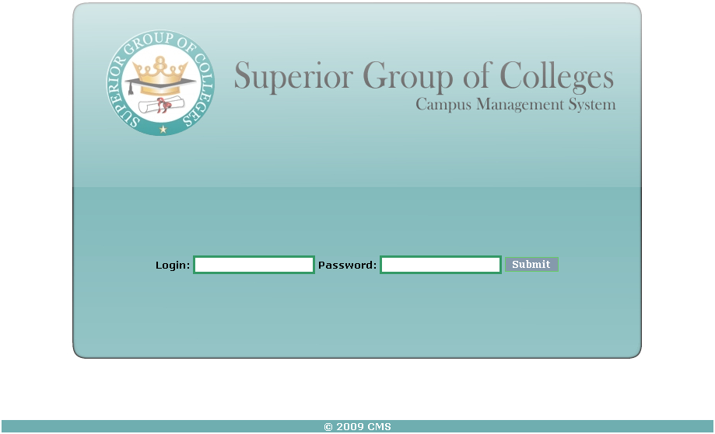

**6.15.2 Admin Main Page**

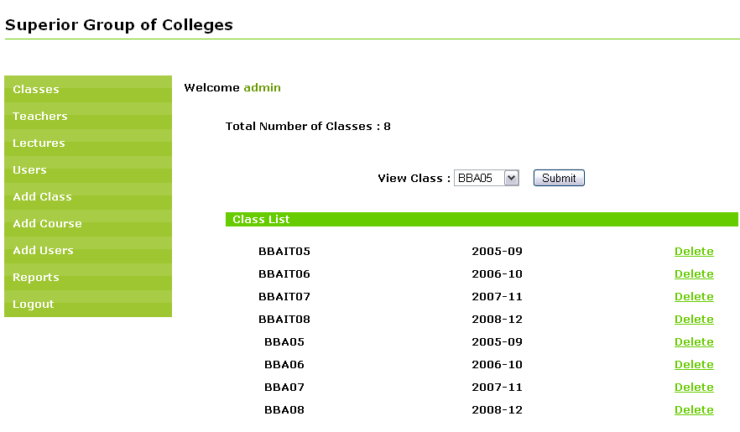

**6.15.3 Classes Pages**

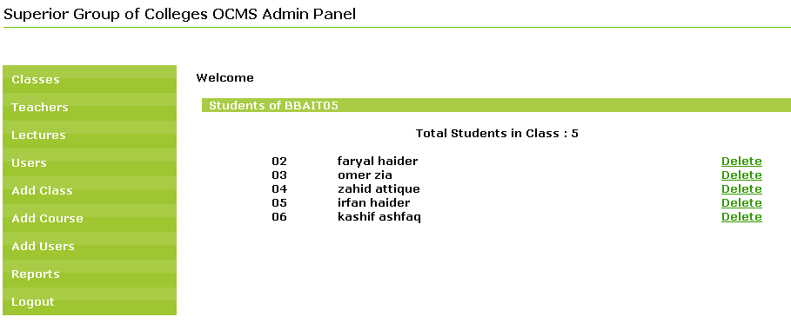

**6.15.4 Teachers Page**

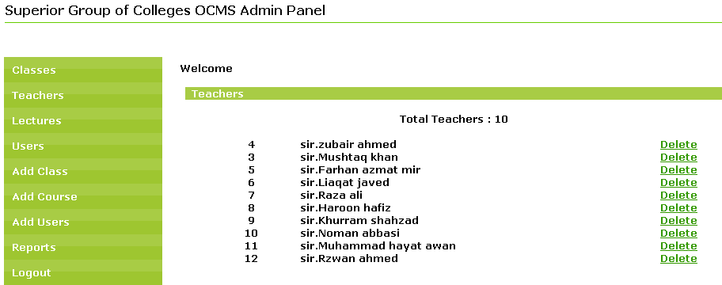

|  |  |
| --- | --- |
|  |  |

|  |
| --- |
|  |

**6.15.5 Lectures Page**

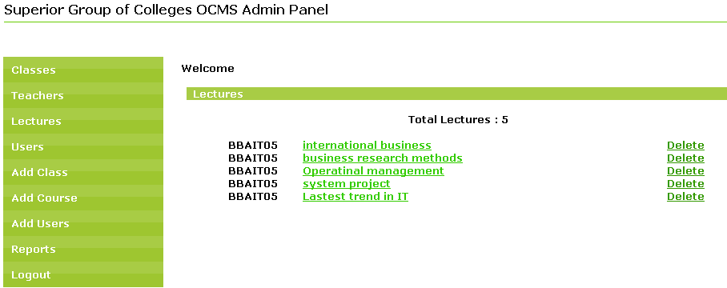

**6.15.6 Users Page**

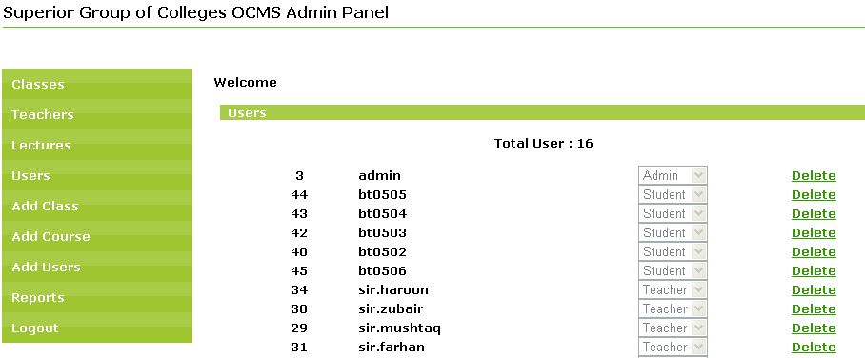

**6.15.7 Add Class Page**

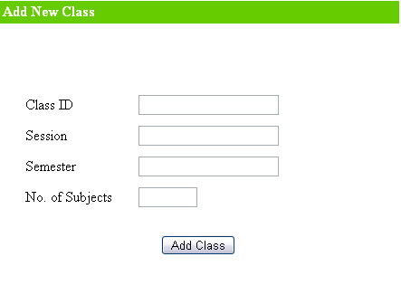

**6.15.8 Add Course Page**

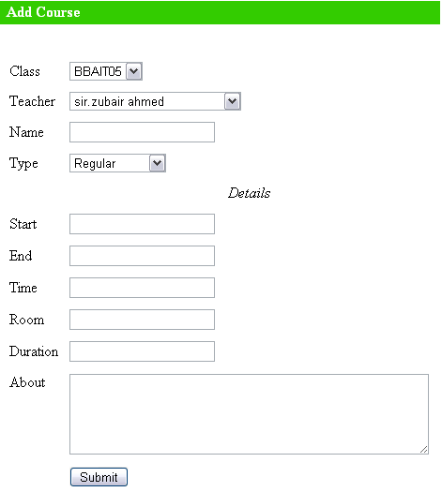

**6.15.9 Add User Page**

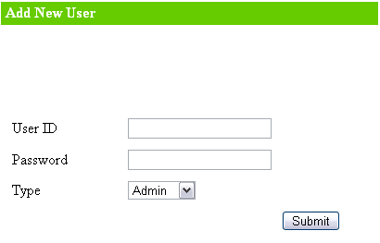

**6.15.10 Reports Page**

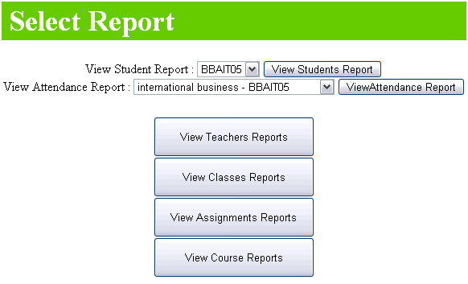

**6.15.11 Students Main Page**

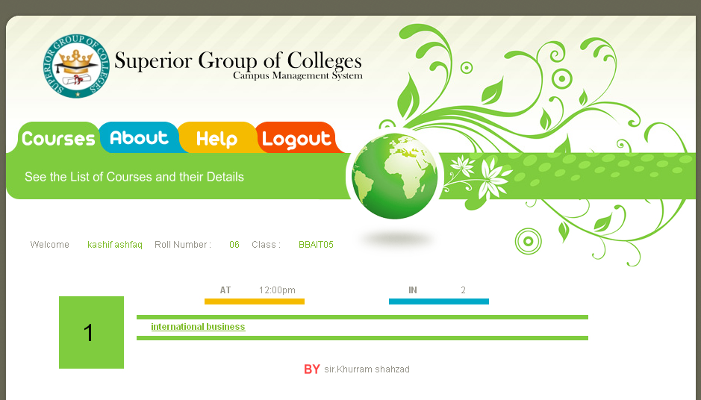

**6.15.12 Teachers Main Page**

